**Experiment 4**

**Collaboration and Remote Repositories:**

### Clone a remote Git repository to your local machine. Solution:

To clone a remote Git repository to your local machine, follow these steps:

1. Open your terminal or command prompt.
2. Navigate to the directory where you want to clone the remote Git repository. You can use the cd command to change your working directory.
3. Use the git clone command to clone the remote repository. Replace <repository_url> with the URL of the remote Git repository you want to clone. For example, if you were cloning a repository from GitHub, the URL might look like this:

$ git clone <repository_url> Here's a full example:

$ git clone https://github.com/username/repo-name.git

Replace https://github.com/username/repo-name.git with the actual URL of the repository you want to clone.

1. Git will clone the repository to your local machine. Once the process is complete, you will have a local copy of the remote repository in your chosen directory.

You can now work with the cloned repository on your local machine, make changes, and push those changes back to the remote repository as needed.

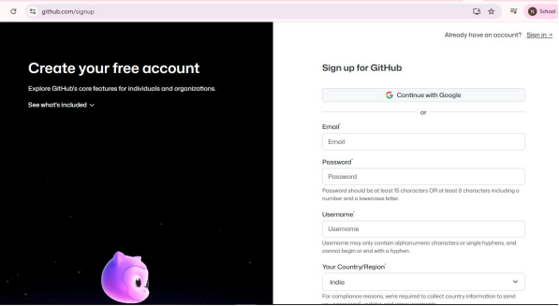

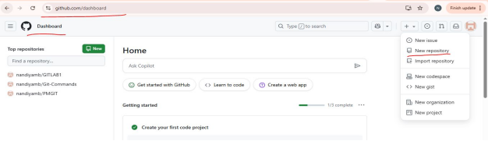

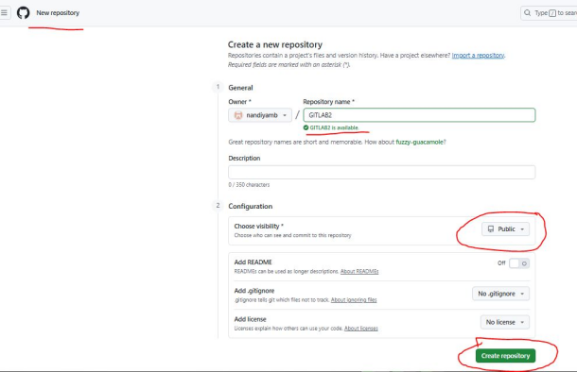

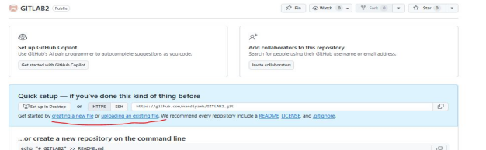

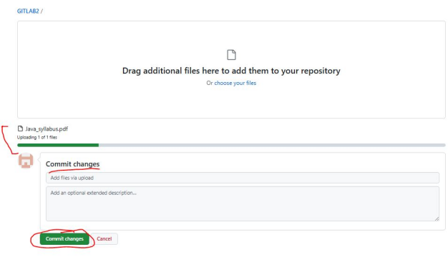

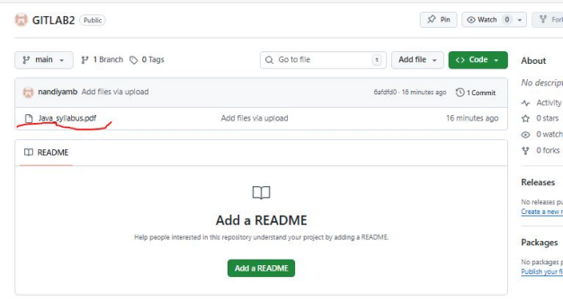



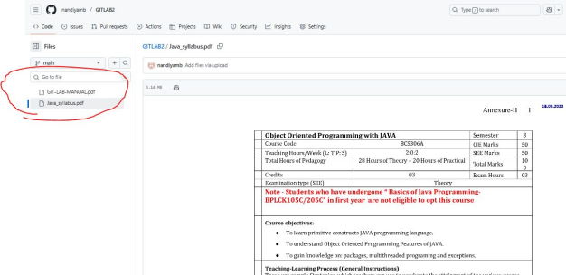

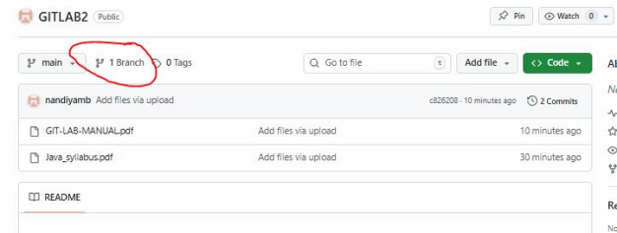

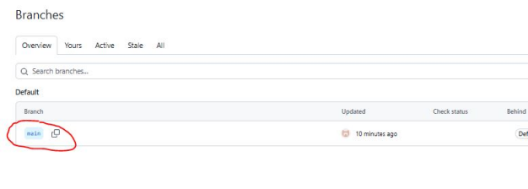

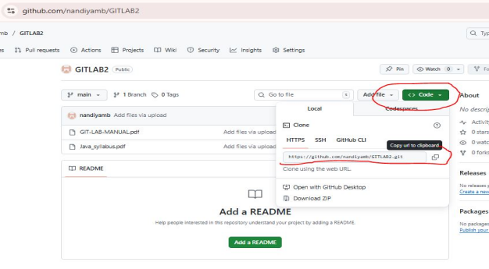

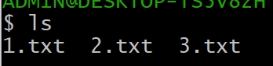

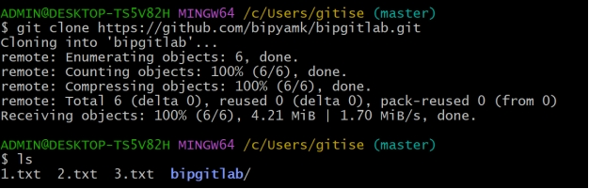

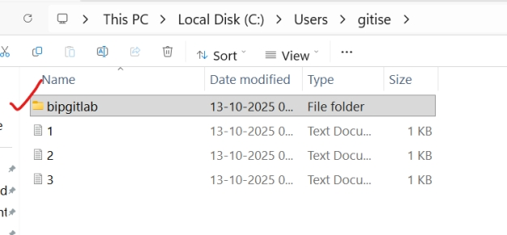

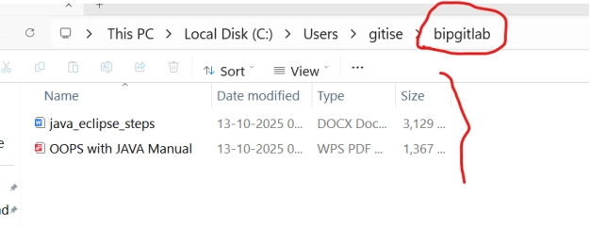

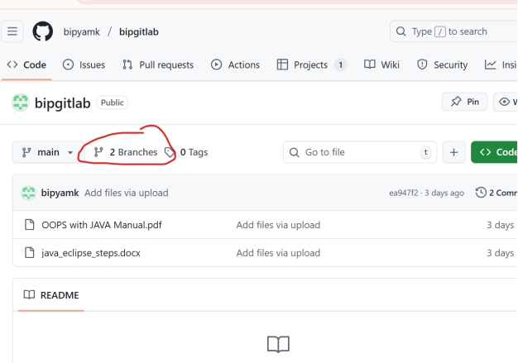

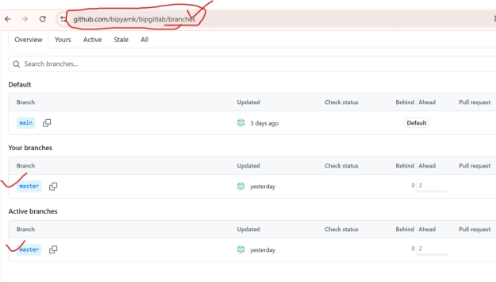

**Experiment 5.**

**Collaboration and Remote Repositories:**

**Fetch the latest changes from a remote repository and rebase your local branch onto the updated remote branch.**

**Solution:**

To fetch the latest changes from a remote repository and rebase your local branch onto the updated remote branch in Git, follow these steps:

1. Open your terminal or command prompt.
2. Make sure you are in the local branch that you want to rebase. You can switch to the branch using the following command, replacing <branch-name> with your actual branch name:

$ git checkout <branch-name>

1. Fetch the latest changes from the remote repository. This will update your local repository with the changes from the remote without merging them into your local branch:

$ git fetch origin

Here, origin is the default name for the remote repository. If you have multiple remotes, replace origin with the name of the specific remote you want to fetch from.

1. Once you have fetched the latest changes, rebase your local branch onto the updated remote branch:

$ git rebase origin/<branch-name>

Replace <branch-name> with the name of the remote branch you want to rebase onto. This command will reapply your local commits on top of the latest changes from the remote branch, effectively incorporating the remote changes into your branch history.

1. Resolve any conflicts that may arise during the rebase process. Git will stop and notify you if there are conflicts that need to be resolved. Use a text editor to edit the conflicting files, save the changes, and then continue the rebase with:

$ git rebase --continue

1. After resolving any conflicts and completing the rebase, you have successfully updated your local branch with the latest changes from the remote branch.
2. If you want to push your rebased changes to the remote repository, use the git push command. However, be cautious when pushing to a shared remote branch, as it can potentially overwrite other developers' changes:

$ git push origin <branch-name>

Replace <branch-name> with the name of your local branch. By following these steps, you can keep your local branch up to date with the latest changes from the remote repository and maintain a clean and linear history through rebasing.

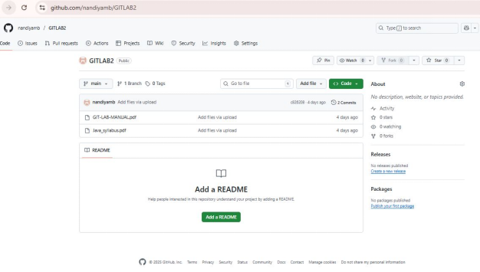

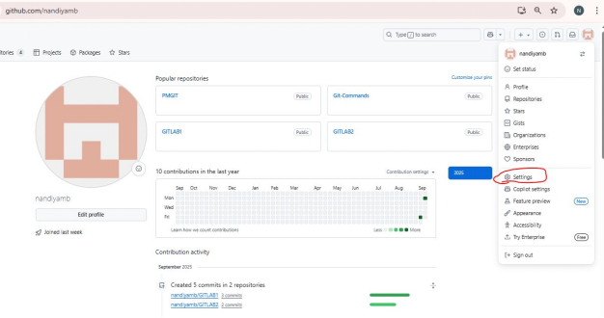

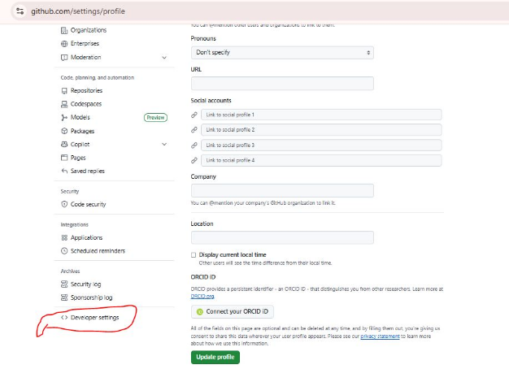

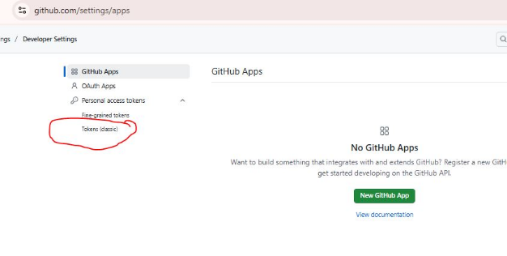

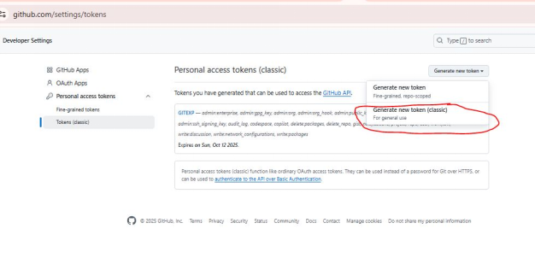

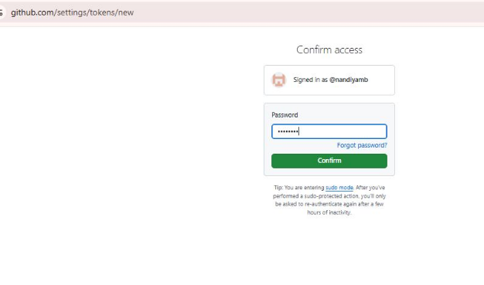

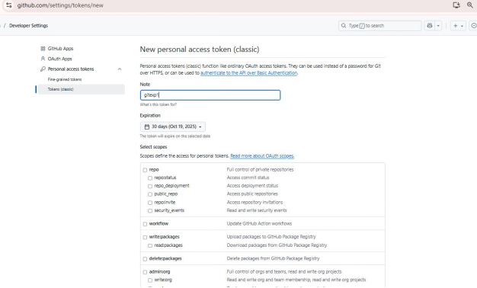

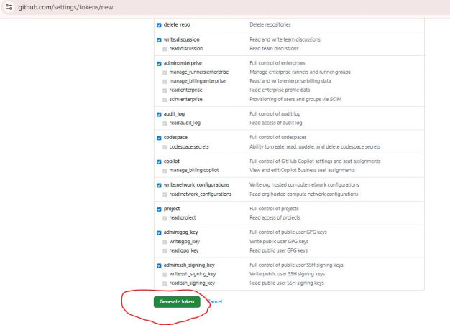

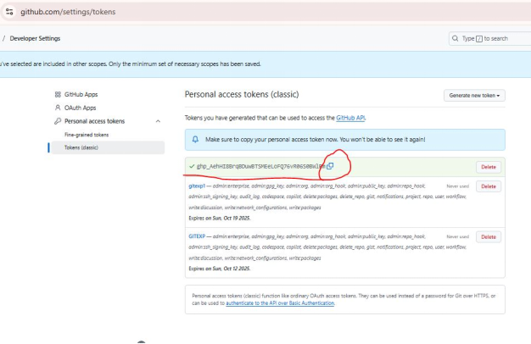

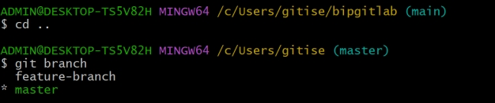

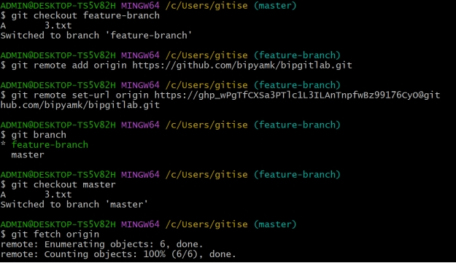

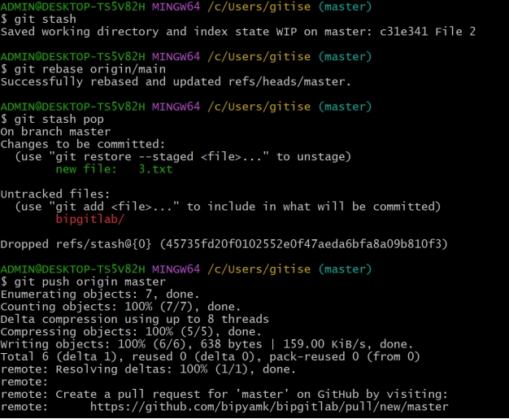

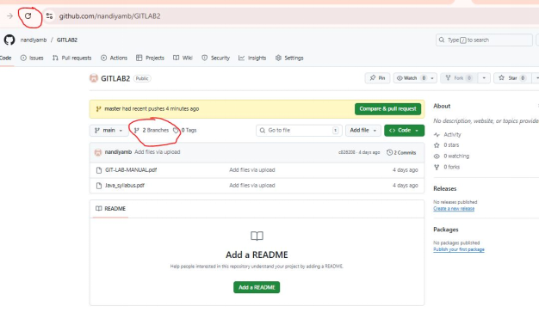

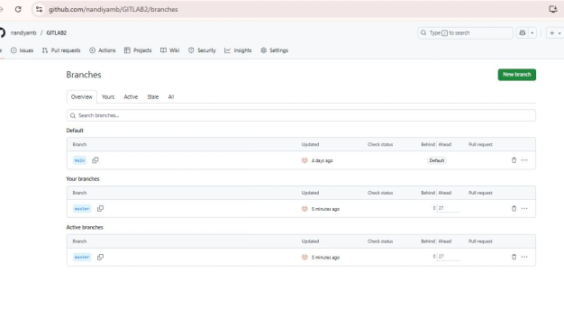

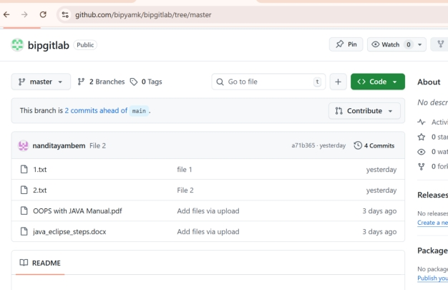

**Experiment 4**

**Collaboration and Remote Repositories:**

### Clone a remote Git repository to your local machine. Solution:

To clone a remote Git repository to your local machine, follow these steps:

1. Open your terminal or command prompt.
2. Navigate to the directory where you want to clone the remote Git repository. You can use the cd command to change your working directory.
3. Use the git clone command to clone the remote repository. Replace <repository_url> with the URL of the remote Git repository you want to clone. For example, if you were cloning a repository from GitHub, the URL might look like this:

$ git clone <repository_url> Here's a full example:

$ git clone https://github.com/username/repo-name.git

Replace https://github.com/username/repo-name.git with the actual URL of the repository you want to clone.

1. Git will clone the repository to your local machine. Once the process is complete, you will have a local copy of the remote repository in your chosen directory.

You can now work with the cloned repository on your local machine, make changes, and push those changes back to the remote repository as needed.



































**Experiment 5.**

**Collaboration and Remote Repositories:**

**Fetch the latest changes from a remote repository and rebase your local branch onto the updated remote branch.**

**Solution:**

To fetch the latest changes from a remote repository and rebase your local branch onto the updated remote branch in Git, follow these steps:

1. Open your terminal or command prompt.
2. Make sure you are in the local branch that you want to rebase. You can switch to the branch using the following command, replacing <branch-name> with your actual branch name:

$ git checkout <branch-name>

1. Fetch the latest changes from the remote repository. This will update your local repository with the changes from the remote without merging them into your local branch:

$ git fetch origin

Here, origin is the default name for the remote repository. If you have multiple remotes, replace origin with the name of the specific remote you want to fetch from.

1. Once you have fetched the latest changes, rebase your local branch onto the updated remote branch:

$ git rebase origin/<branch-name>

Replace <branch-name> with the name of the remote branch you want to rebase onto. This command will reapply your local commits on top of the latest changes from the remote branch, effectively incorporating the remote changes into your branch history.

1. Resolve any conflicts that may arise during the rebase process. Git will stop and notify you if there are conflicts that need to be resolved. Use a text editor to edit the conflicting files, save the changes, and then continue the rebase with:

$ git rebase --continue

1. After resolving any conflicts and completing the rebase, you have successfully updated your local branch with the latest changes from the remote branch.
2. If you want to push your rebased changes to the remote repository, use the git push command. However, be cautious when pushing to a shared remote branch, as it can potentially overwrite other developers' changes:

$ git push origin <branch-name>

Replace <branch-name> with the name of your local branch. By following these steps, you can keep your local branch up to date with the latest changes from the remote repository and maintain a clean and linear history through rebasing.





























